# **The Hong Kong Polytechnic University Department of Land Surveying & Geo-Informatics**

**LSGI 3230A Geomatics Algorithms and Programming**

**Final Project**

Cheng Yu Ching 16055783D

Lai Cin Ting 16058723D

Shi Nuannuan 16055288D

Yu Wai Yan Frances 16055578D

Pan Yue 17018337X

**The Design of the Program in the GUI**

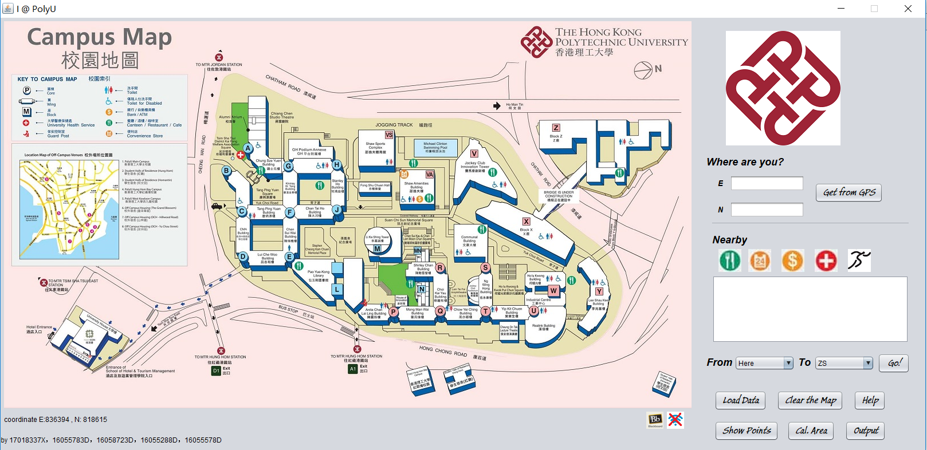

**Software Structure of the Program**

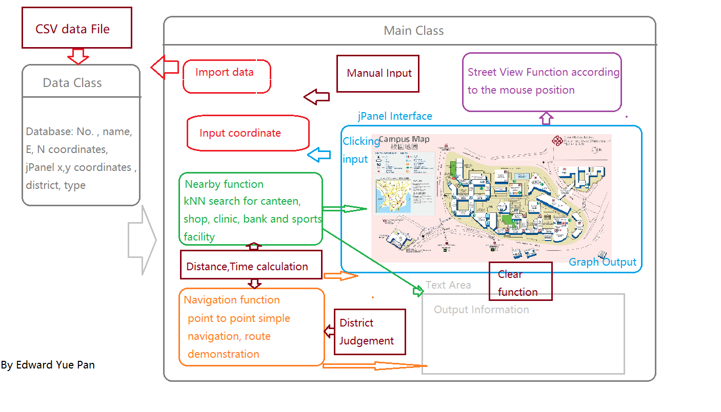

**Main Parts of the GUI Program**

1. A Map showing the PolyU campus with coordinates

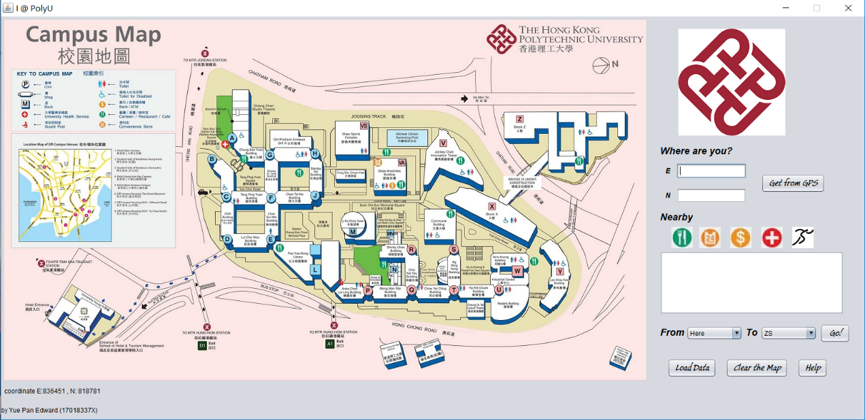

2. Users can either enter the coordinates of their position or press the button “Get from GPS” to select their current position. Then, an icon of a little yellow man will display your location in the map.

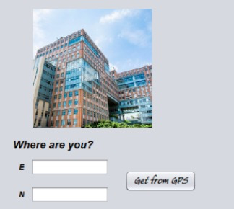

|  |
| --- |
|  |

3. A jTextArea for showing the searching result like the facility nearby, their distance from here and assumed time.

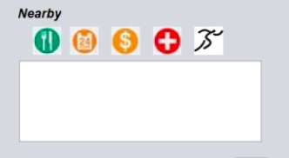

4. 2 Combobox for navigation, users select their position and destination, then press “Go!”, then it will show the route from the position to the destination.



5. Click the ‘Load data’ button the have file selection

Click the ‘Clear the map’ button, then all the messy points and lines will disappear

Click the ‘Output’ button to output the information in the Textarea into a txt.

Click the ‘Show Points’ button to show all the data points on the map interface for future GIS operation.

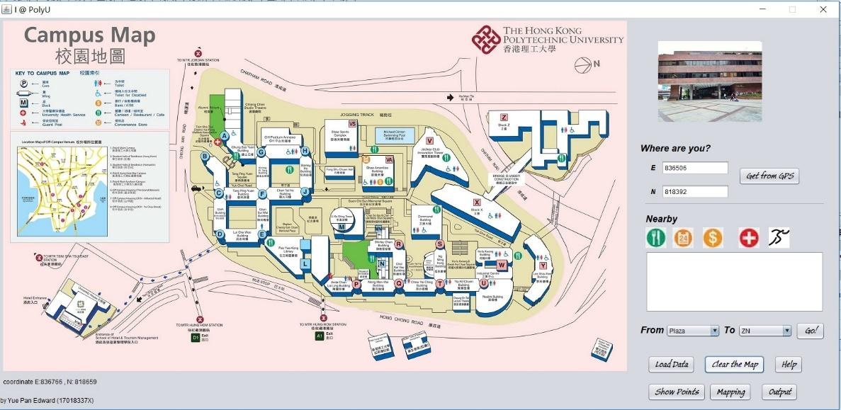

**Inputting the Data from a csv. File**

|  |  |
| --- | --- |
| **Step 1:** Using the “Load Data” button to start selecting the data file needed to be input. |  |
|  |  |
| **Step 2:** Choosing the data file which will be used for the program. In this case, the csv file “data 4” was selected. |  |

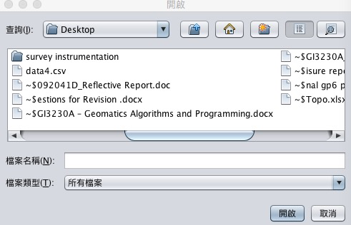

**Step 3:** When the data file was selected, the path of the file will be shown in the text field. Also, the program will read the data inside the file.

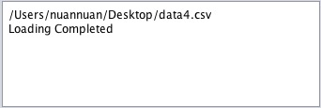

**The Coding Method for Inputting the csv. Data File**

|  |  |
| --- | --- |
|  | **(Line 437-439)**  Using the file selection function of the java program. ‘showOpenDialog ’ to show the dialog for selecting the data file.‘jTextArea1’ for showing the path and ‘Loading Completed’ of the selected file on the assigned text area.  **(Line 440-442)**  Creating myInput for reading the data from the selected file and creating an array ‘textdata’ to store the data from the selected file.  **(Line 446-463)**  Using myInput to read the data from the selected file. If the file is not found, there is logger for logging the error.  **(Line 446-467)**  Splitting the data of the array ‘textdata’ by using a ‘,’. Then storing  the data according to their type. For numerical data, the data type will be changed from ‘String’ to ‘double’. |

After importing data, we can show all the data points on the map just by clicking the button ‘Show Points’.

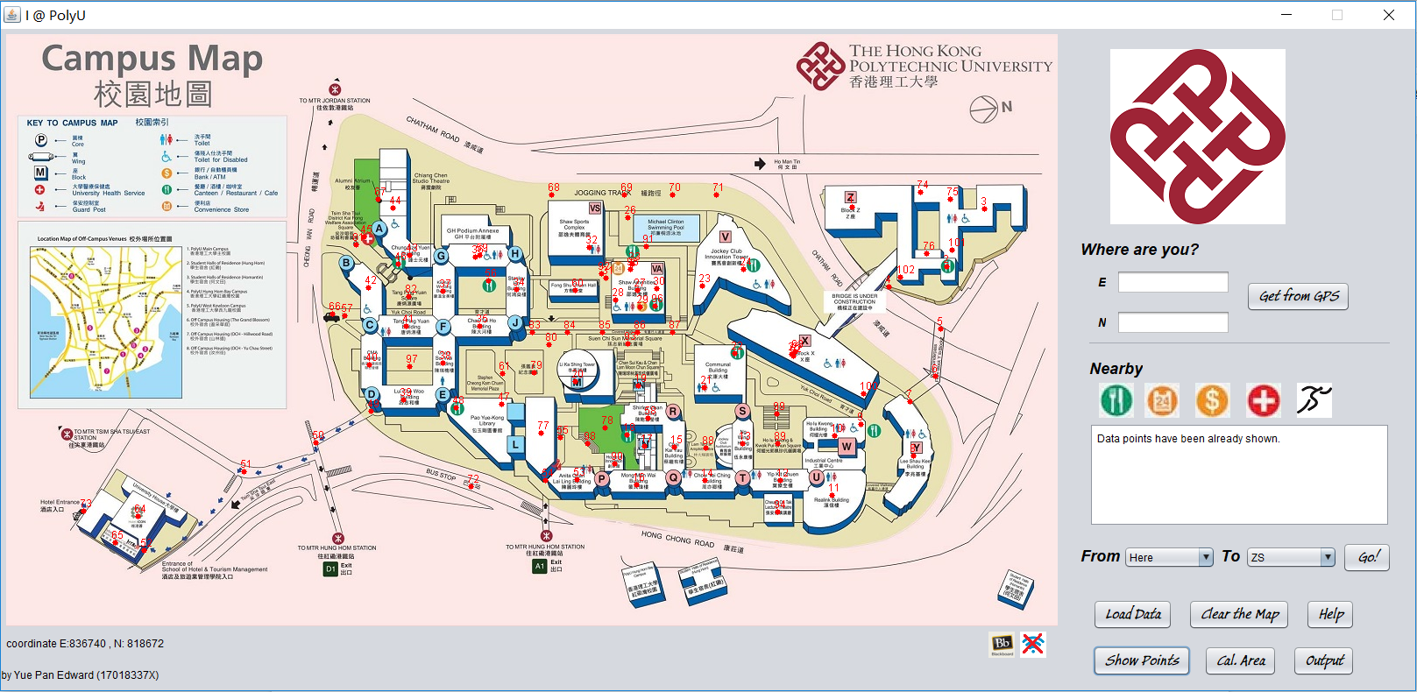

**Street View Service**

**Step 1:** Using the mouse to click on the corresponding area of the map, the photo of that area will appear.

In this case, I point to the area of Z core, the photo of Z core will appear on the right hand corner.

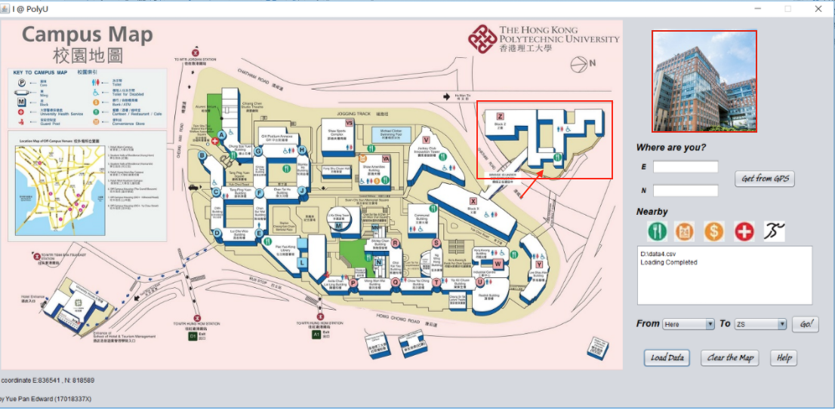

In other case, if I point to the area of V core, the photo of V core will appear on the right-hand corner.

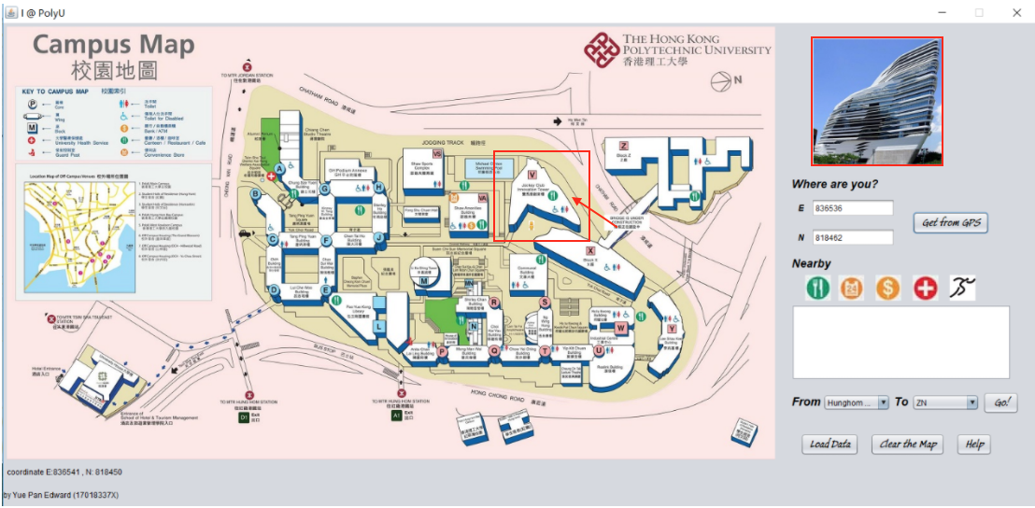

**The Coding Method for Street View Service**

|  |  |
| --- | --- |
|  | The campus map is divided into many rectangles subareas. Each subarea has its own landmark or street view. We have record each rectangle’s upper right and lower left coordinates on the map.  **(Line 484-485)**  we get the coordinate of mouse on the panel. When mouse is clicked, the program would judge in which area the mouse is clicked and then show the associated landmark or street view on the right-hand corner.  The mouse coordinate on the panel is mx and my, which is compared with each rectangle’s minx,miny,maxx,maxy coordinate. |

**Get from GPS**

**Step 1**: Users can either enter the coordinates of their position or press the button “Get from GPS” in order

to select their current position. Then, an icon of a little yellow man will display your location in

the map. Also, the coordinates will be shown.

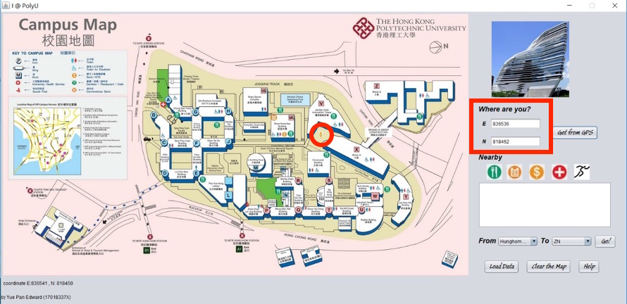

From this image, users have entered the coordinates and the yellow man was appeared in the map.

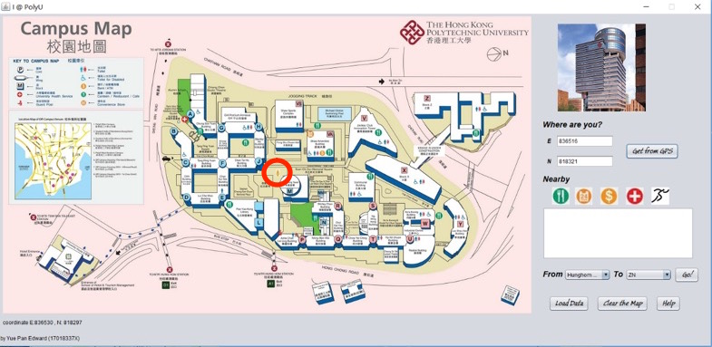

This is another example using the “Get from GPS” function. The corresponding pictures and coordinates

will be shown on the assign area.

**The coding method of “Get from GPS”**

|  |  |
| --- | --- |
|  | **(line 42)**  Define the variable GPSon for indicating whether the current location is determined.  **(line 46-47)**  Determine the affine transform parameter between world coordinate and image coordinate.  **(line 585-599)**  If GPSon equal to 1, the following operation would be done. Then a small yellow man icon would be shown on the map if we click on any position of the map.  **(line 600-609)**  The world coordinate according to HK 1980 grid is calculated from the image coordinate and then it would be shown in the textbox.  **(line 624-628)**  When the button ‘Get from GPS’ is clicked, GPSon would be set to be 1. |

**Location based service (LBS)**

**Step 1**: Select different buttons of nearby.

**Step 2**: Showing the five most nearby canteens, their distance from here and the assumed time

[the blue points]

**Step 3:** Showing the three most nearby gyms, their distance from here and the

assumed time [the cyan points]

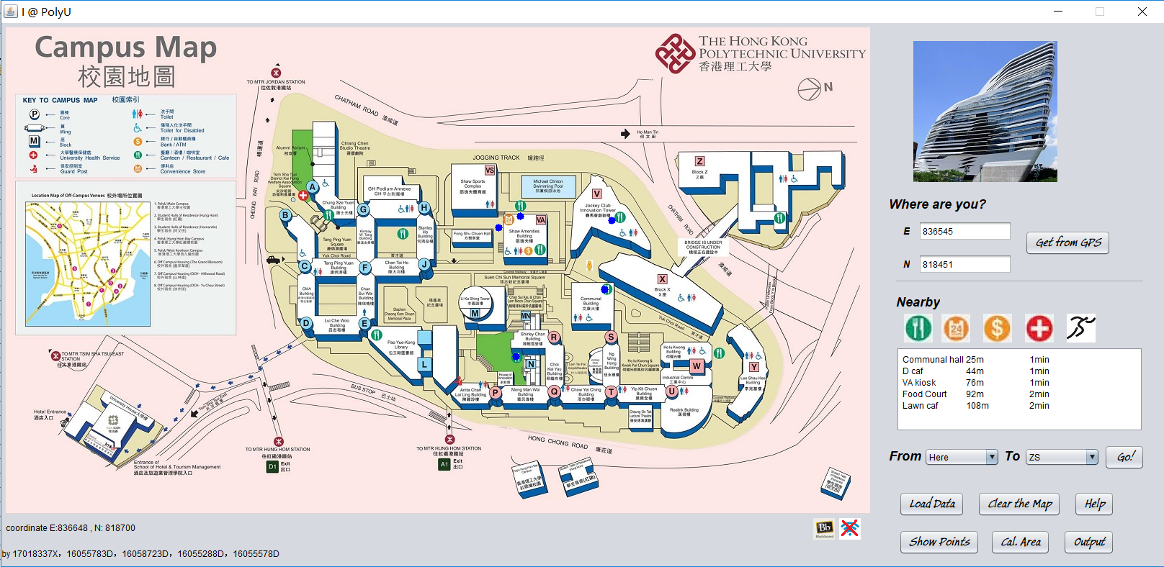

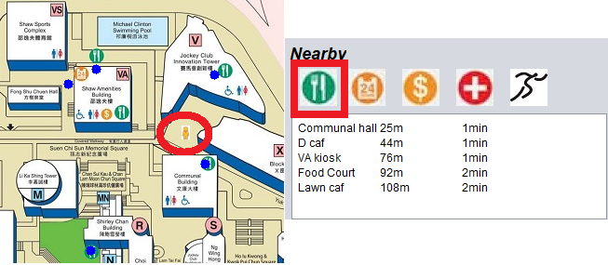

**The Coding Method for Location based service**

|  |  |
| --- | --- |
|  | **(line 633-637)**  Judge if the data has been imported. If it has not been imported yet, information would be shown in the textArea.  **(line 638-644)**  Get the current location  **(line 645-651)**  Search corresponding target objects among the imported data and put them into an array to record their distance from current location.  **(line 652-663)**  Do the bubble sorting for the distance array and get the K nearest neighbor of the current location.  **(line 665-610)**  Draw the target KNN points on the map using the class’s representing color. |

**Navigation**

**Step 1:** Users select their position and destination, then press “Go!”. For example ZS to TU



**Step 2:** It will show the route from the position to the destination with a black line.

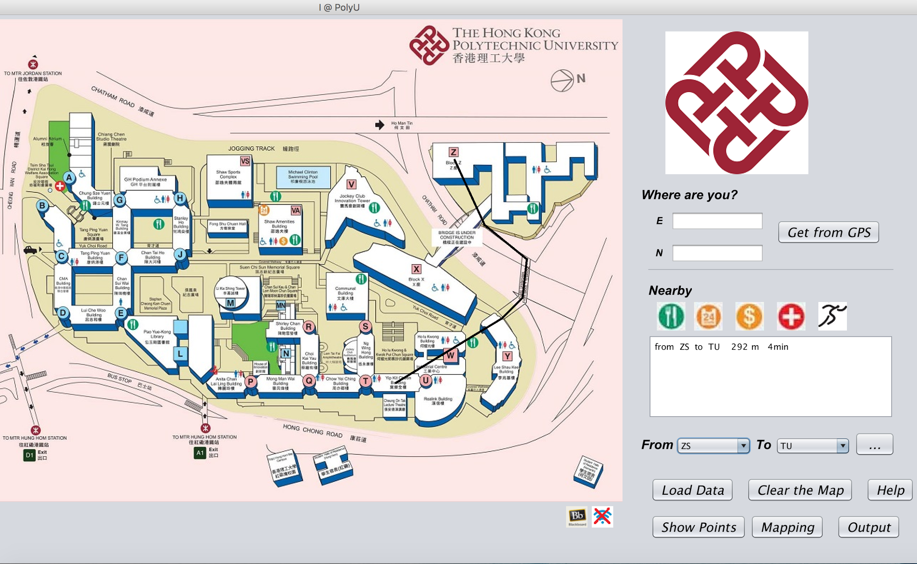

**Step 3:** The route, distance, assumed time are displayed.

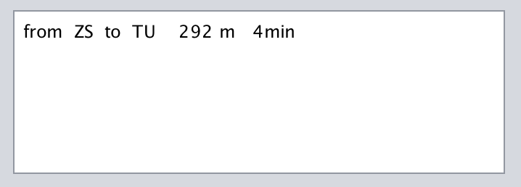

**Step 4:** There are other example is chooce From “here” To “ZN. First, I select a point on the map, for example W core (the coordinates appear in the TextField E and N). Then, press “Go!”. It will generate the route from here to ZN.

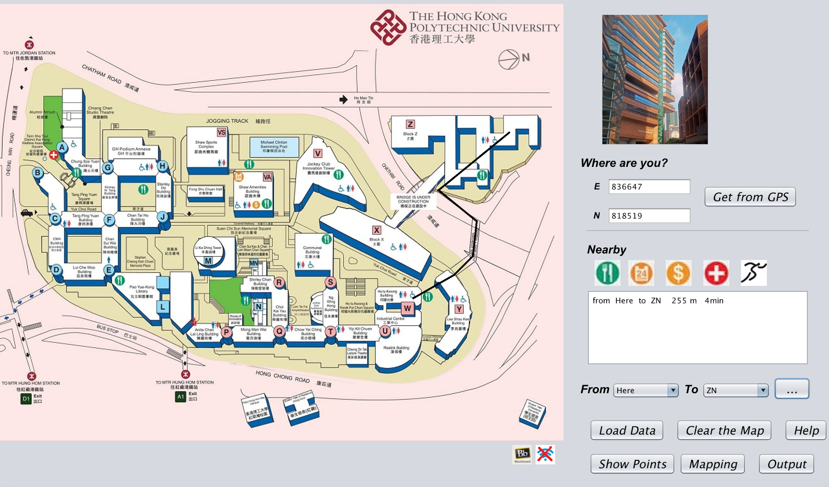

**Step 5:** There are many choices for the route.

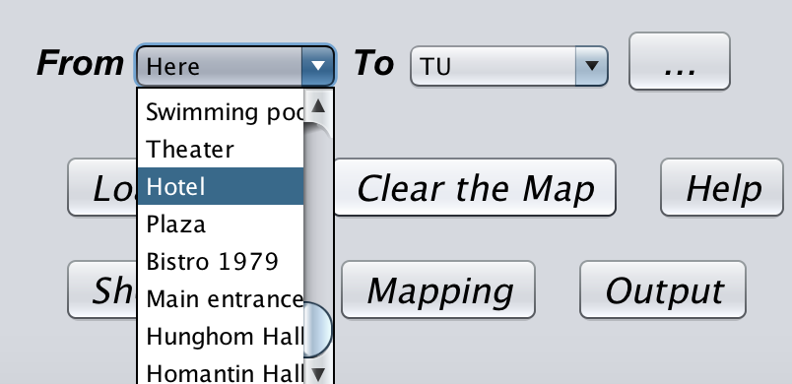

**The Coding method for Navigation**

|  |  |
| --- | --- |
|  | **(Line 676-684)**  To begin with, make sure data has been imported. Then the origin and destination of the navigation are recorded from the combomboxes. Some useful variables are defined.  (**Line 691-725)**  The campus is divided into three parts: (1: Z core area, 2: main campus area, 3: ICON area) This division is due to the fact that route between them are limited to certain tunnel or overpass. In this case, we also take the halls off campus into consideration. For each case, we set the best route for navigation. The origin point id and destination point id is recorded. Then the total distance can be calculated using the imported data.  **(Line 747-772)**  After judging to which divide the origin and destination belong, we can determine the best route between them. Then the route is drawn on the map and the distance and expected consuming time is calculated.  **(Line 865-869)**  We need to consider some complex circumstance like traveling from hall to hall.  **(Line 870-872)**  The final navigation results about the origin, destination, distance and expected consuming time are shown in the textArea. |

**Clear the map**

**Step 1:** After many operation, the map interface seems messy with lines and points

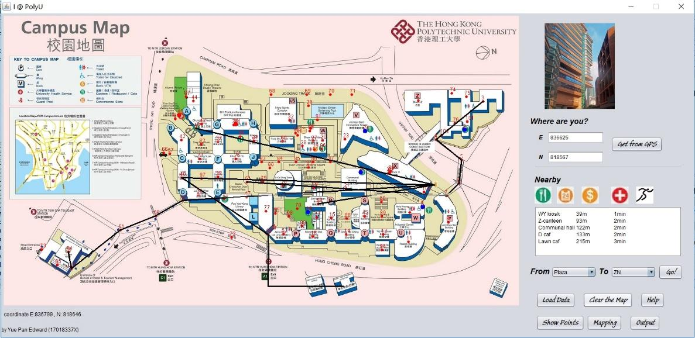

**Step 2:**  Click the ‘Clear the map’ button, then all the messy points and lines will disappear.



**The Coding method for Clear the map**

|  |  |
| --- | --- |
|  | **(Line 1032-1035)**  When the button ‘Clear the map’ is clicked, we reset the panel with a new blank map to cover the former one. |

**Output**

**Step 1:** Click the ‘Output’ button to output the information in the TextArea into a txt.

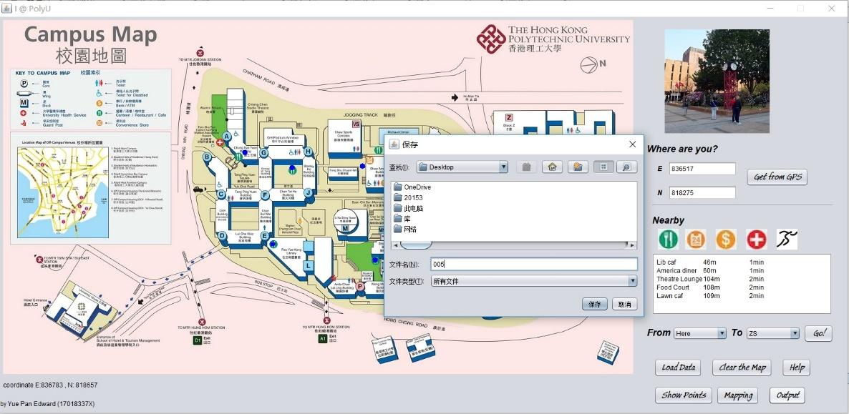

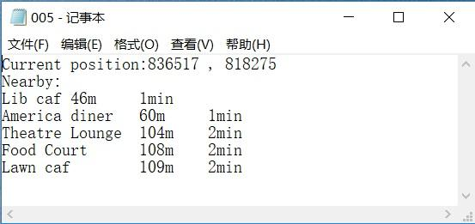

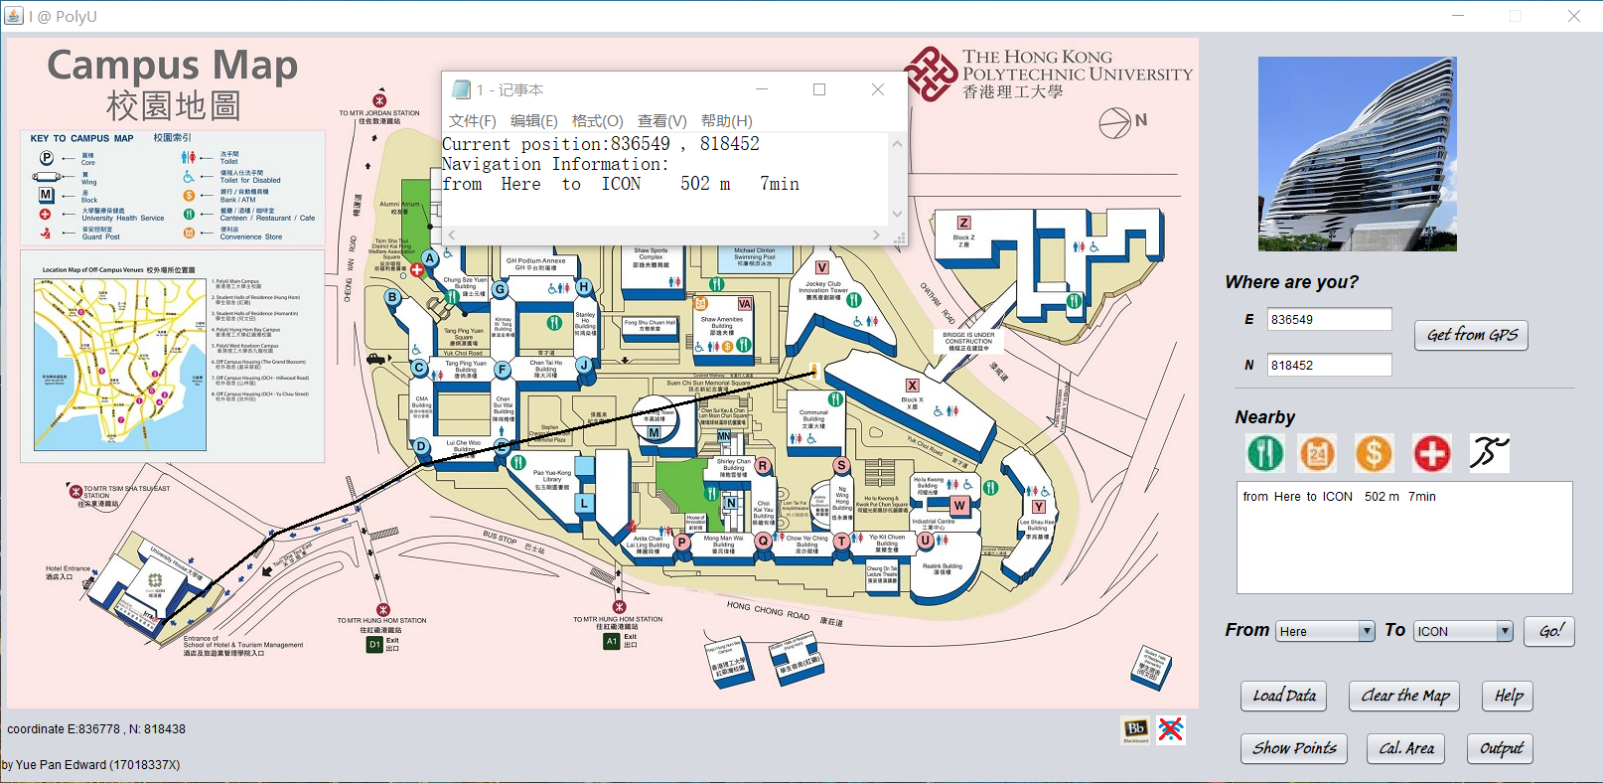

**The Coding method for output**

|  |  |
| --- | --- |
|  | **(Line 1075-1088)**  Define and initialize a file object and set the output file address  **(Line 1090-1102)**  Judge which function of the software is used currently and write some corresponding information into the file. Then the texts in the textArea are also written into the file. |

**Calculate polygon area**

**Step 1:** Please draw a convex polygon on the map by pinpointing points continuously and then clicking the button ‘done’.

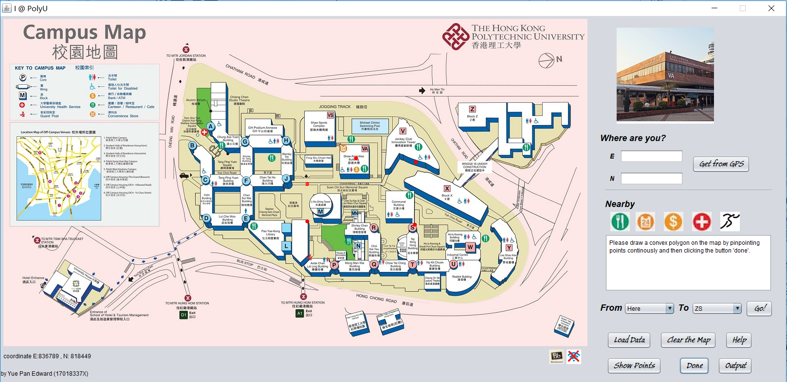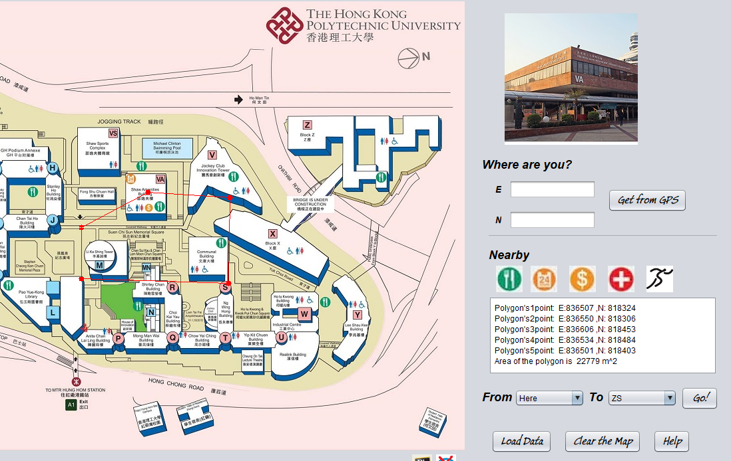

**The Coding method for calculate polygon area**

|  |  |
| --- | --- |
|  | **(Line 45-52)**  Some useful variables and arrays are defined or initialized. Arrays polygonx, polygony, polygonX, polygonY are used to save the image and world coordinates of the points that the polygon consists.  **(Line 609-618)**  If the variable calarea equals to 1, once we click the map, we can draw a point on the clicked position. This point would be saved as a vertex of the polygon.  **(Line 1151-1157)**  When the button’ Cal.Area’ is clicked, if the variable calarea equals to 0, information indicating how to draw the polygon would be shown in the textArea. What’s more, calarea would be set to be 1 and the button’ s text would be reset as ‘Done’.  **(Line 1158-1163)**  When the button ‘Done’ is clicked, we would judge whether the number of vertexes is larger than 2. If vertex number is not enough, warning information will be shown.  **(Line 1164-1182)**  If the vertex number is enough, lines between them would be drawn on the map to compound the polygon.  Then the area of the polygon can be calculated using the convex polygon area algorithm in lab7. The final result would be shown in the textArea together. |

**Web Links**

**Step 1:** Click the small Wifi sign on the right bottom side and then you can open some website just by clicking the campus map



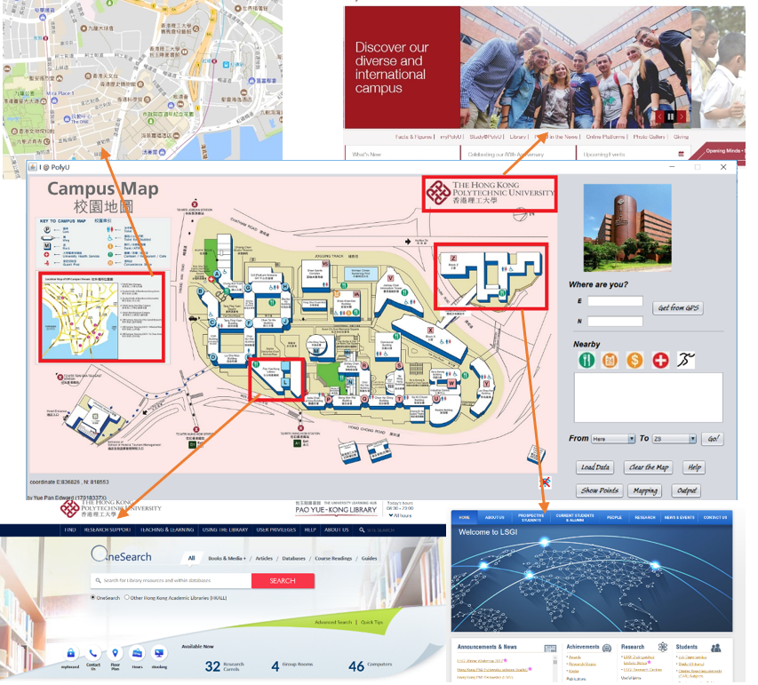

**The Coding method for Web links**

|  |  |
| --- | --- |
|  | **(line 1124-1133)**  If the wifi button is clicked, which means the wifi is connected, the variable wifi will be set to be 1 and the wifi button’s icon will be reset.  **(line 561-570)**  If the variable wifi is 1, when we click the small map on the left side that show PolyU’s location in Kowloon area, a web page of Google Map would be open.  **(line 571-579)**  If the variable wifi is 1, when we click the PolyU logo on the right upper-side, PolyU homepage would be open.  **(line 1135 to 1145)**  If the variable wifi is 1, when we click the blackboard icon below the map, blackboard web page would be open. We can then upload our group project to it. |